Table of Contents
Compiling and processing two large datasets 2
A. Cause-specific death rates 2
Sources of mortality data 2
Information in mortality records 3
Assigning and grouping causes of death 5
Objectives 7
Breakdown of monthly causes of death 7
B. Meteorological data 11
Sources of cause of meteorological data 11
Objectives 13
Converting gridded meteorological to county-level data 13
Overview of output 13
Applicability to other studies 14
Discussion 15

Figure 1: Tree structure of selected causes of death 9

Table 1: Selected causes of death 8

Compiling and processing two large datasets

Before I can make any analysis of seasonal mortality (Chapter XX) or a particular cause of death’s relationship with temperature anomaly (Chapters XX-XX), I will need to ensure that the cause-specific monthly mortality and temperature inputs, both large and complicated sources of information not designed with my intended usage in mind, are valid and useful. I will need to pre-process the data and make them suitable as a modelling input, which requires a great deal of work and attention to detail.
In this chapter I give an overview of monthly mortality and temperature data sources. I then present my new generalisable method for finding population-weighted monthly meteorological statistics, converting grid square temperature into county-level temperature values. This method forms an essential component of the subsequent modelling process and is generalisable to be capable of turning commonly-found large gridded meteorological datasets, such as ERA-Interim, into district-specific summaries anywhere in the world with a shapefile available.

Cause-specific death rates

First, I describe how I deal with finding a reliable data source for death records, how I make choices in categorising death records by location, and age and sex, and then how I group categories into a mutually exclusive and collectively exhaustive combination of causes of death, where I prepare causes of death records in a logical way in relation to their seasonal variation and responses to temperature variation.

Sources of mortality data
Sources of data on causes of death are available in various forms. These include vital registration (VR) systems, population censuses, mortality surveillance systems, verbal autopsy studies, hospital data, police records, mortuary records, and household surveys. These sources, however, are not consistently matched in terms of coverage (percentage of the population which is monitored), quality (accuracy of diagnosis in records) and completeness.¹
Of these, VR systems are the most common, covering 18.8 million deaths in 2005, around 36% of the total number of deaths globally that year.² Of VR systems, those with medically-certificated causes of death are generally considered the highest quality of VR data available.³ However, VR systems are generally concentrated in developed nations, with developing countries in Africa and Asia being born and dying without any official trace.⁴ In 2003, the World Health Organization (WHO) estimated that only 64 countries had effectively complete death registration, mostly in American, European and the Pacific regions.¹ As such, ecological studies from VR systems are generally restricted to countries such as the United States.

Information in mortality records
When calculating death rates at the subnational level, we need accurate information on the decedent’s place of residence. This is available on VR system records. However, in the United States, when a death occurs, it may take place in a hospital or care home which is in a different US county from which the person is registered. There are mis-classification issues originating from this phenomenon at the county level in the United States. One study found a 14% error rate in recording county of residence for decedents from one county in Texas.⁵ This potentially leads to under-reporting deaths in some counties, while over-reporting in other. But while there are clear issues around county-level place of residence registration in the United States, there is little evidence of such a phenomenon at state level.
Race and ethnicity may also be misclassified. For death certificates in the United States, they are determined by a third party. This is in contrast with a census, where race and ethnicity are self-reported. This mis-match between methods of collecting information about race and ethnicity can lead to unrealistic death rates for particular ethnic groups. While death rate reporting for whites and blacks in the United States has been of high quality since the late 1960s, death rates from Hispanic and Asian or Pacific Islander (API) populations have only gradually improved over time, while the quality of reporting in the American Indian or Alaska Native (AIAN) population has remained poor, with up to 40% misclassification in this group.⁶
To calculate death rates by age, we require the VR system’s record of age at death to be reliable. However, even this aspect of the death certificate can sometimes be susceptible to error with relatively poorer age reporting for non-white Americans in comparison to white counterparts.⁷
While VR data are typically the highest quality data, in many other parts of the world there is not a long enough time series or consistency of data to allow analysis of the data to take place.¹ In contrast with high-income countries, which have used VR systems for over 50 years, other countries have no viable VR system. Other possibilities for these kind of studies include mortality surveillance systems, VA studies and cause-specific disease registry systems.
To create death rates for a cause of death (${death rate}_{state-month-year}$), population data is also necessary, with the number of deaths in a particular state, month and year (${deaths}_{state-month-year}$) in the numerator and the respective population (${population}_{state-month-year}$) in the denominator:
$${death rate}_{state-month-year}=\frac{{deaths}_{state-month-year}}{{population}_{state-month-year}}$$
A census, whereby each member of a population is counted manually by registering members of a household, provides the most reliable way of obtaining population data. In the United States, the census is decennial. The last census there occurred in 2010.⁸ The next one due is in 2020. While a census takes place only every ten years, methods have been developed over the years which reliably interpolate population by age group, sex and county in intercensal years with census years as boundary conditions. Population data in the United States is therefore publicly available by county, year, centred around July. This is available from from the from the NCHS bridged-race dataset for 1990 to 2016 (https://www.cdc.gov/nchs/nvss/bridged_race.htm) and from the US Census Bureau prior to 1990 (https://www.census.gov/data/developers/data-sets/popest-popproj/popest.html).
In temperature countries like the United States, it is well-established that deaths rates in humans vary throughout the year.^{9–11} Publicly-available records of death from VR systems in the United States contain the month of and day of week of death. Therefore, identifying a death record by exact day and date is not possible. A month timescale allows perceptible variations in within-year death rates, and it is not as sensitive to fluctuations in deaths evident in smaller time scales. If calculating monthly death rates, monthly population data counts are required, not commonly available. Therefore, we require a method to generate monthly population estimates from the yearly ones.

Assigning and grouping causes of death
With VR data each death is assigned a single underlying cause. This will typically take place shortly after a patient dies, and a physician fills out the death certificate. In the United States, this will include filling out five or more lines listing the chain of events which led up to a death.¹² The final underlying cause of death is processed using an algorithm, e.g. the Automated Classification of Medical Entities (ACME), which will determine the underlying cause of death.^{13,14} This underlying cause of death is coded using the international classification of diseases (ICD) convention. The version of ICD coding used by physicians varies every time a new coding system is updated.
The ICD system is currently on its 11th revision (ICD-11), released by the World Health Organization (WHO) in 2018 (https://www.who.int/classifications/icd/en/). However, each country unilaterally decides when to adopt the latest ICD codes for recording underlying causes of death. For example, the United States is currently still using its own variants of the ICD-10 coding,¹⁵ ICD-10 Clinical Modification (ICD-10-CM) and the ICD-10 Procedure Coding System (ICD-10-PCS), adopted in 1999, nine years after being endorsed by the Forty-third World Health Assembly (https://www.cdc.gov/nchs/icd/icd10cm.htm). The ICD-10 revision of the ICD coding system contains thousands of five-digit codes to which a death can be assigned. The detail of the level of death is very high. Using each one individually for an epidemiological study would quickly present issues regarding small absolute numbers of cases. Research in public health policy therefore often requires that these causes of death are grouped into larger families. Though the ICD revisions provide a methodology to convert ICD codes into ‘chapters’, these groupings are too broad for specific public health interest.
When research spans multiple decades of mortality records in one country, such as in my work in the United States, there will almost inevitably be a change in ICD coding convention during that time. This is complicated by the expansion of the numbers of ICD codes, which has expanded from 200 original codes to nearly 15,000.¹⁶ This requires creating a unifying list of causes that can be applied across ICD revisions using a bridge between ICD revisions.
I will therefore need to consider how I create a mutually exclusive and collectively exhaustive causes of death within an ICD revision, cause of death mappings across ICD revisions, and coherent groupings of causes of death with similar seasonality and temperature aetiology over time, age and/or space.

Objectives
My objectives in designing the cause of death classification included capturing significant causes of death within the country; grouping causes that possess comparable seasonal behaviour and aetiological pathways to temperature vulnerability; clustering mortality outcomes which contain similar seasonality behaviour over time, age and/or space; generating monthly cause of death rates by age group, sex and state; and avoiding small numbers issues by collecting mutually exclusive and collectively exhaustive causes of death.

Breakdown of monthly causes of death
I used data on all 85,453,845 deaths in the contiguous USA (i.e., excluding Alaska and Hawaii) from 1980 to 2016. During this period, there were 400,331 deaths in Alaska and Hawaii, or 0.5% of total deaths in the USA during this period. We used data on deaths by sex, age, underlying cause of death and state of residence in the contiguous USA from 1980 to 2016 through the National Center for Health Statistics (NCHS) (https://www.cdc.gov/nchs/nvss/dvs_data_release.htm) and on population from the NCHS bridged-race dataset for 1990 to 2016 (https://www.cdc.gov/nchs/nvss/bridged_race.htm) and from the US Census Bureau prior to 1990 (https://www.census.gov/data/tables/time-series/demo/popest/1980s-county.html).
I coded the underlying cause of death according to the international classification of diseases (ICD) system (in the United States, 9th revision of ICD from 1980 to 1998 and 10th revision of ICD thereafter). Based on the Global Burden of Disease 2016 cause of death structure,¹⁷ I developed mappings of ICD-9 and ICD-10 to a mutually exclusive and collectively exhaustive set of four broad causes and several sub-causes of death which are of public health interest in the United States and elsewhere. Grouping the deaths in this way provides a relatively detailed view of cause composition while avoiding small number concerns in modelling given the monthly and subnational nature of the data (Table XX).
Table 1: Selected causes of death
Cardiorespiratory diseases |  | Cancers | Injuries |  | Other causes
Cardiovascular diseases | Respiratory diseases | Cancers | Unintentional injuries | Intentional injuries | Other causes
Ischaemic heart disease | Chronic obstructive pulmonary disease (COPD) |  | Transport | Assault
Cerebrovascular disease | Respiratory infections |  | Falls | Intentional self-harm
 |  |  | Drownings
Other cardiovascular diseases | Other respiratory diseases |  | Other unintentional injuries

I adapted the categories to those which would exhibit shared monthly variation and with outcomes relevant to changes in temperature, as well as being relevant to the US burden of disease. For example, while deaths from cancers are a significant burden of disease in the US and globally, with an estimated 609,640 deaths in the US (https://www.cancer.gov/about-cancer/understanding/statistics) and 9.6 million deaths worldwide in 2018,¹⁸ new cases are not generally considered as sensitive to temperature changes, and so are grouped as “Cancers” here. In contrast, cardiorespiratory diseases are recognised as sensitive to temperature and are a large burden of disease in the US. Sub-causes of cardiorespiratory diseases also exhibit different seasonal properties by age group and sex, and potentially vulnerability to temperature anomaly, and therefore I separate them out here.
I also show the tree structure in my mutually exclusive and collectively exhaustive cause of death hierarchy in Figure XX. The detailed causes of death can be aggregated to higher levels, such as grouping together all cardiovascular diseases or types of injuries. The causes of death can also be further aggregated one more level, such as grouping all cardiorespiratory diseases.
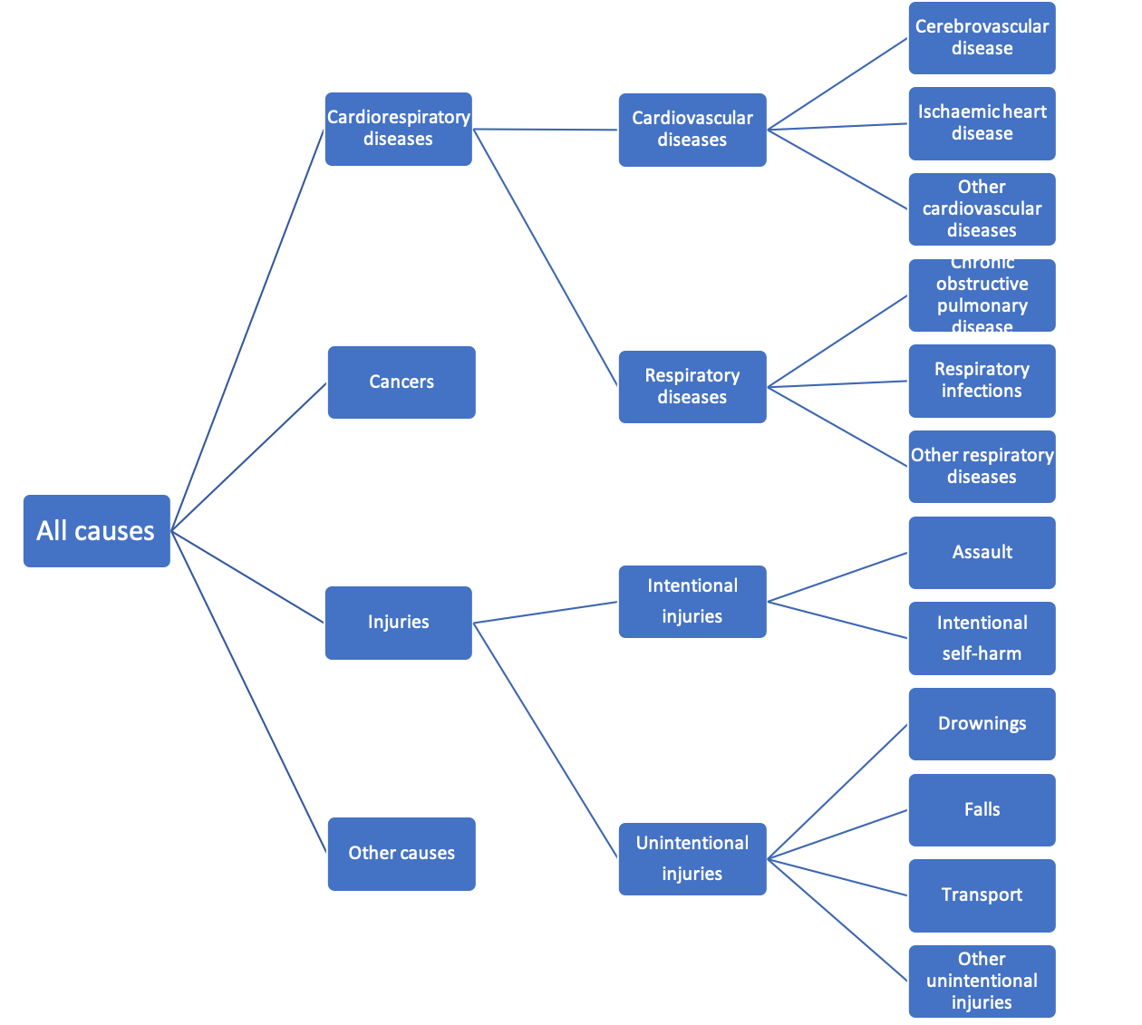
Figure 1: Tree structure of selected causes of death
We used two competing models to generate monthly population estimates using yearly values as boundary conditions, one of which modelled exponential growth in months between years, with the other modelling linear growth. The monthly population results were not sensitive to our choice. We thus calculated monthly population counts through linear interpolation, assigning each yearly count to July.
We divided the data by sex and the following ten age groups: 0-4, 5-14, 25- 34, 35-44, 45-54, 55-64, 65-74, 75-84, 85+ years. We calculated monthly death rates for each age and sex group, both nationally and for sub-national climate regions. Death rate calculations accounted for varying length of months, by multiplying each month’s death count by a factor that would make it equivalent to a 31-day month.
Cardiorespiratory diseases accounted for XX% and XX% of total deaths in 1980, and XX% and XX% of total deaths in 2016, for males and females respectively. In the period 1980-2016, XX boys and men and XX girls and women died from cardiorespiratory diseases in the contiguous USA. (Figure XX). Deaths from cardiorespiratory diseases have been associated with changes in temperature. [ref] In particular, ischaemic heart disease, cerebrovascular disease (or strokes), chronic obstructive pulmonary disease (COPD) and respiratory infections have all separately been identified as sensitive to local temperature change. [ref] Over time, cardiorespiratory deaths have generally gone down (Figure XX). Age-standardized death rates (ASDRs) have decreased by XX% during the period (Figure XX). This is replicated by most major sub-causes of death within cardiorespiratory deaths (Figure XX).
Cancers accounted for XX% and XX% of total deaths in 1980, and XX% and XX% of total deaths in 2016, for males and females respectively (Figure XX). There is a lack of solid evidence that deaths from cancers is associated with temperature. Over time, deaths from cancers have gone down (Figure XX). ASDRs have decreased by XX% during the period (Figure XX).
Deaths from injuries accounted for XX% and XX% of total deaths in 1980, and XX% and XX% of total deaths in 2016, for males and females respectively (Figure XX). There is limited evidence that deaths from injuries are associated with temperature. [ref]. Over time, deaths from injuries have decreased, with the picture for the sub-groups generally more complicated (Figure XX).

Meteorological data

Next, I describe how I deal with finding a reliable data source for meteorological records, how I have developed methods to process meteorological the records for use as an input to my epidemiological model and how I have generalised my methods for use in other studies globally.

Sources of cause of meteorological data
It has long been recognised that a record of weather over a period of time is useful for XX. As such, records of local weather data have been collected for many centuries in certain places, such as the UK, which begin nationwide from the late 1800s. [ref] Coverage of land and sea has generally increased over time in developed nations, with XX% of Europe covered by one functioning weather station in 20XX, compared with XX% in 19XX. [ref] This coverage is generally not matched by developing nations, with Africa’s coverage remaining static and even decreasing in some areas.
Due to the relative expense of upkeep of weather stations and in-situ measurements, the ‘satellite revolution’ of the 1970s created a powerful potential new source of weather tracking. However, there are also discrepancies between satellite and in-situ measurements, creating conflicts with regards to which one should be trusted.
Modelling the climate and weather systems has developed in lock-step with advancements in computing power and technology over the last few decades. [[[Statistics for comparison]] However, using pure model output alone will currently not be a reliable source of weather information, as microphysics (that is, physics at scales smaller than is resolvable using current computing power) relies on parameterization of certain processes, leading to a reliable forecast horizon window (that is, more likely correct than random) of only a few days for precipitation, up to a couple of weeks for temperature. Hindcast performance, or ability to replicate weather from the past from a known starting point, is similarly limited. [ref]
A very good compromise between all of the above options is data from reanalysis. In reanalysis, a physical model is used which goes forward a particular time step, while calling on recorded data from weather measurements to steer the model, repeatedly correcting the trajectory of a variable over time. There are many datasets which employ this method of generating output, such as … ERA-Interim has global coverage across several decades, with many different potentially relevant weather variables to health. [ref] While certain localised models, such as PRISM, focus on the United States, ERA-Interim is a good option if looking for a method which can be generalised comparably worldwide. [[[Comparison with PRISM in terms of summaries]]]
However, the output of ERA-Interim is generally unusual for those in public health research. It comes in an unusual .nc format. Further, it comes as gridded data. For those interested in using county-level or state-level data in the United States, there is a gap between the output and the ability for those interested in public health to use it. A climate service, or preparation of climate and weather for usage by professionals who are not necessarily experts in the meteorological field, is necessary here.
As such, I have developed a method of converting gridded population datasets to XX using shapefiles from open-source mapping data. I have used this method in my research in this thesis. It has further applicability outside of the bounds of my interests, and the same method has been used in research in health effects of pollution. The code will be released as an R package [[[TBC]]]

Objectives
My objectives involved designing a method of taking gridded reanalysis weather data and converting it to US county-level summaries; creating population-weighted monthly means by US state; generalising method to enable application for other variables locations and studies.

Converting gridded meteorological to county-level data
Several stages are involved in creating county-level temperature summaries based on gridded data. Each year comes as a global dataset which intersects each county in the USA. I then took each county, assigning a unique ID to each grid square, and calculated an area-weighted value for each county (Figure XX).
The next stage of calculation was to create a state-wide population-weighted average for each age group and sex for the entire contiguous United States. This would ensure that at the scale of state, the temperature value assigned would reflect the experience of those within the state during that month. I carried out this calculation by age group and sex so that if, for example, the population distribution at any time was significantly different between age groups and/or sexes, they temperature value calculated would accurately reflect that (Figure XX).
Figure XX gives a map of the average temperatures for each month across the contiguous United States during 1980-20116. Having built up population-weighted values, I then generated monthly temperature statistics. I developed candidate temperature statistics by thinking of ways to represent deviations from the mean temperature, as well as extremes. [[[Copy and paste from the temperature paper about describing]]]

Overview of output
Table XX gives a list of temperature variables generated. These were generated by summarising daily values over a month. They were designed to reflect changes in both the centre of the temperature distribution as well as the extreme.
We conducted sensitivity analyses to assess how much our results might depend on the temperature metric used to generate anomalous temperature. First, instead of building our monthly temperature anomalies based on daily mean temperatures, we used daily maxima and minima. These measures were strongly correlated to those generated from daily means (Table XX), and therefore we did further use daily maxima or minima in calculations.
- Add summary table of states and anomalies
To calculate the magnitude of temperature anomaly by state and month, we first calculated 30-year (long-term) norm temperatures (from 1980-2009) for each month in each state. We calculated for 30 years because it is the duration used in climate assessments.¹⁹ We subtracted these long-term norm temperatures from respective monthly temperature values to generate a temperature anomaly time series for each month and year in each state (Figure XX). The temperature anomaly metric measures the extent that temperature experienced in a specific month, year and state is warmer or cooler than the long-term norm to which the population of each state has acclimatised. These values can be different for neighbouring months in the same state, and neighbouring states in the same month.
When generating several meteorological values, it was relevant to examine how correlated they were with each other. Table XX shows the level of correlation between them.

Applicability to other studies
As well as designing the methodology for the purposes of my research, it is applicable to other studies in public health anywhere in the world. My methodology was used in developing a dataset in a study to research the loss in life expectancy from air pollution in the United States. [ref]. This example demonstrates the flexibility of the method I developed, which can be applied globally. This is due to the dataset, ERA-Interim, having worldwide coverage.

Discussion
I designed a mutually exclusive and collectively exhaustive set of causes of death which are relevant both to seasonality of mortality, as well as sensitivity to inter-year variation attributable to temperature fluctuation. This work establishes a framework via which I can examine seasonality and temperature effects on an entire set of causes of death. I was able to create a consistent mapping across ICD-9 and ICD-10 codes, over which there were challenges for maintaining groupings of causes of death over time. I also developed a model to estimate monthly population based on yearly estimates, necessary to calculate death rates.
The main new work came from developing a generalisable methodology of converting gridded meteorological variables into area-weighted county-level and state-level population-weighted data. This method is applicable across the entire ERA-Interim dataset (i.e., the entire world), and compares well with existing datasets, such as PRISM. The main benefit of the gridded data conversion for the United States is that other meteorological variables can be employed. For my study, I explored various measures of temperature behaviour and concluded that the deviation from the anomaly would represent the best single variable as an input for associating changes in temperature with changes in mortality. The fact that this method is applicable for other studies is evidenced by the annual temperature and relative humidity being calculated for a study of the effect of pollution on life expectancy loss in the United States. [ref]
My processing monthly death rates and monthly temperature summaries therefore sets up the analysis both of seasonality of mortality by consistent causes of death over time and association of temperature with mortality variation to estimate the potential effects of climate change.
References
1 Mathers CD, Fat DM, Inoue M, Rao C, Lopez AD. Counting the dead and what they died from: An assessment of the global status of cause of death data. Bull World Health Organ 2005.
2 Lozano R, Naghavi M, Foreman K, et al. Global and regional mortality from 235 causes of death for 20 age groups in 1990 and 2010: A systematic analysis for the Global Burden of Disease Study 2010. Lancet 2012. DOI:10.1016/S0140-6736(12)61728-0.
3 Boerma JT, Stansfield SK. Health statistics now: are we making the right investments? Lancet. 2007. DOI:10.1016/S0140-6736(07)60364-X.
4 Setel PW, Macfarlane SB, Szreter S, et al. A scandal of invisibility: making everyone count by counting everyone. Lancet. 2007. DOI:10.1016/S0140-6736(07)61307-5.
5 Pierce JR, Denison A V. Place-of-residence errors on death certificates for two contiguous U. S. counties. Popul Health Metr 2006. DOI:10.1186/1478-7954-4-6.
6 Arias E, Heron M, National Center for Health Statistics, Hakes J, US Census Bureau. The Validity of Race and Hispanic-origin Reporting on Death Certificates in the United States: An Update. Vital Health Stat 2 2016.
7 Elo IT, Preston SH. Estimating African-American Mortality from Inaccurate Data. Demography 2007. DOI:10.2307/2061751.
8 Central statistics office. 2010 Census of population and housing. 2012.
9 Fowler T, Southgate RJ, Waite T, et al. Excess winter deaths in Europe: A multi-country descriptive analysis. Eur J Public Health 2015; 25: 339–45.
10 Healy JD. Excess winter mortality in Europe: A cross country analysis identifying key risk factors. J Epidemiol Community Health 2003; 57: 784–9.
11 Campbell A. Excess winter mortality in England and Wales: 2016 to 2017 (provisional) and 2015 to 2016 (final). Stat Bull Off Natl Stat 2017.
12 Messite J, Stellman SD. Accuracy of death certificate completion: The need for formalized physician training. J Am Med Assoc 1996. DOI:10.1001/jama.275.10.794.
13 Glasser JH. The quality and utility of death certificate data. Am J Public Health 1981. DOI:10.2105/AJPH.71.3.231.
14 Lu TH, Tsau SM, Wu TC. The Automated Classification of Medical Entities (ACME) system objectively assessed the appropriateness of underlying cause-of-death certification and assignment. J Clin Epidemiol 2005. DOI:10.1016/j.jclinepi.2005.03.017.
15 World Health Organisation. ICD-10 International Statistical Classification of Diseases and Related Health Problems. 2011 DOI:10.1016/j.jclinepi.2009.09.002.
16 World Health Organization. History of the development of the ICD. World Heal. Organ. 2019. https://www.who.int/classifications/icd/en/HistoryOfICD.pdf (accessed March 31, 2019).
17 Naghavi M, Abajobir AA, Abbafati C, et al. Global, regional, and national age-sex specifc mortality for 264 causes of death, 1980-2016: A systematic analysis for the Global Burden of Disease Study 2016. Lancet 2017. DOI:10.1016/S0140-6736(17)32152-9.
18 The Global Cancer Observatory. Cancer fact sheet. 2019 DOI:L11\n10.1051/0004-6361/201016331.
19 Wallace JM, Hobbs P V. Atmospheric science: An introductory survey: Second edition. 2006 DOI:10.1016/C2009-0-00034-8.

